**Demo 6 #4**

1. The Python demo program implements the fourth-order difference equation with 8 variables to store past values (i.e., 8 delay units). This is the direct form implementation. But a fourth-order difference equation can be implemented using just 4 variables to store past values (i.e., 4 delay units). The canonical form can be used for this purpose. See the block diagram in Fig. 7.2.4 on page 274 of the text book ‘Introduction to Signal Processing’ by Orfanidis  http://www.ece.rutgers.edu/~orfanidi/intro2sp/orfanidis-i2sp.pdf

The software implementation of the canonical form is shown in Equation 7.2.5 on the same page.  Modify the Python demo program to implement the difference equation using the canonical form. Instead of 8 delay units, this form should have just 4 delay units. Verify that the output produced by this implementation is the same as the output produced by the demo program.

**Python code:** canonical_06.py

import pyaudio

import wave

import struct

import math

from myfunctions import clip16

wavfile = 'author.wav'

# wavfile = 'sin01_mono.wav'

print('Play the wave file %s.' % wavfile)

# Open wave file (should be mono channel)

wf = wave.open( wavfile, 'rb' )

# Read the wave file properties

num_channels = wf.getnchannels() # Number of channels

RATE = wf.getframerate() # Sampling rate (frames/second)

signal_length = wf.getnframes() # Signal length

width = wf.getsampwidth() # Number of bytes per sample

print('The file has %d channel(s).' % num_channels)

print('The frame rate is %d frames/second.' % RATE)

print('The file has %d frames.' % signal_length)

print('There are %d bytes per sample.' % width)

# Difference equation coefficients

b0 = 0.008442692929081

b2 = -0.016885385858161

b4 = 0.008442692929081

# a0 = 1.000000000000000

a1 = -3.580673542760982

a2 = 4.942669993770672

a3 = -3.114402101627517

a4 = 0.757546944478829

# Initialization

w1 = 0.0

w2 = 0.0

w3 = 0.0

w4 = 0.0

p = pyaudio.PyAudio()

# Open audio stream

stream = p.open(

format = pyaudio.paInt16,

channels = num_channels,

rate = RATE,

input = False,

output = True )

# Get first frame from wave file

input_string = wf.readframes(1)

nwf = wave.open('wav_canonical.wav','w')

nwf.setnchannels(num_channels)

nwf.setsampwidth(width)

nwf.setframerate(RATE)

while len(input_string) > 0:

# Convert string to number

input_tuple = struct.unpack('h', input_string) # One-element tuple

input_value = input_tuple[0] # Number

# Set input to difference equation

x0 = input_value

# Difference equation

w0 = x0 - a1*w1 - a2*w2 - a3*w3 - a4*w4

y0 = b0*w0 + b2*w2 + b4*w4

# Delays

w4 = w3

w3 = w2

w2 = w1

w1 = w0

# Compute output value

output_value = int(clip16(y0)) # Integer in allowed range

# Convert output value to binary string

output_string = struct.pack('h', output_value)

# Write binary string to audio stream

stream.write(output_string)

nwf.writeframes(output_string)

# Get next frame from wave file

input_string = wf.readframes(1)

print('* Finished')

stream.stop_stream()

stream.close()

p.terminate()

nwf.close()

**Matlab code :** make_and_use_filter.m

**Comments :**

From the link above is :

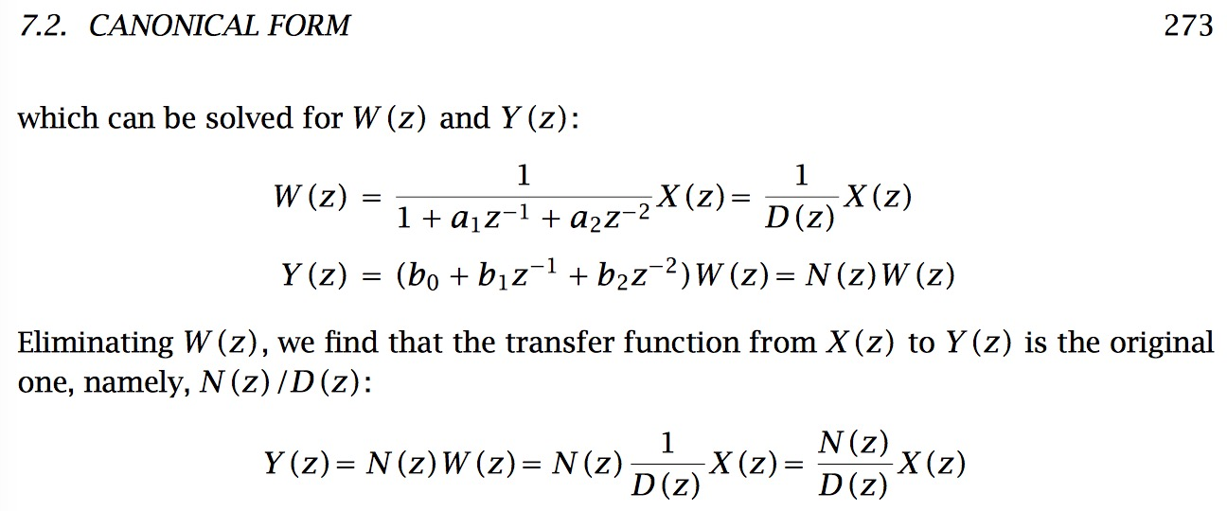

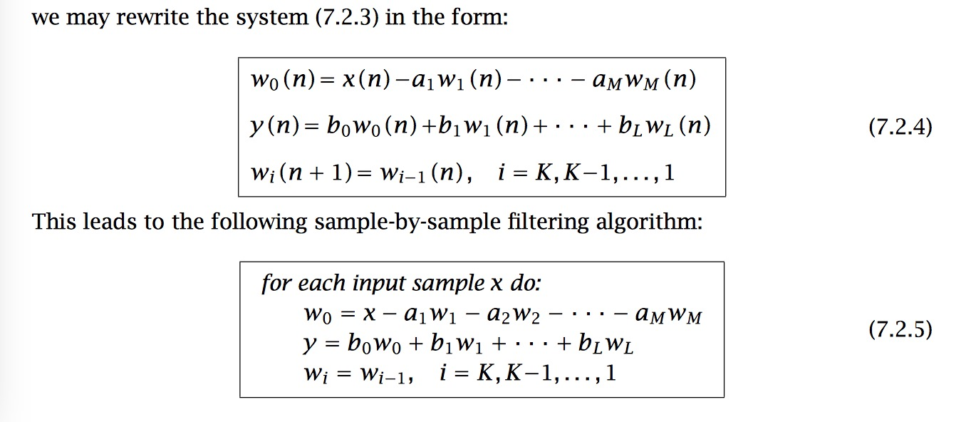

It shows a canonical form that use w0 to make an intermediary. So I just apply these equations in python and use only 4 delays of w0 to make the filter.

Plus, I modify the maltab code so that it could not only plot the direct form wave but also this canonical form wave in the same figure, it shows the code work well. (The figure are shown below)

